**Store Manager Documentation**

# Introduction

# Project Title : Store Manager

# Team ID : NM2025TMID37055

# Team Leader : Preyasi C- preyasi06cp@gmail.com

# Team Members :

1.PRATHIKSHA J – [prathiksha162006@gmail.com](mailto:prathiksha162006@gmail.com)

2. PREETHI A – [preethisuji05@gmail.com](mailto:preethisuji05@gmail.com)

3.PRISKILLAH S [–ppriski511@gmail.com](mailto:–ppriski511@gmail.com)

# .

# Project Overview:

# Purpose:

The store manager is responsible for overseeing the day to day operations of the store , ensuring smooth functioning ,meeting sales goals , and delivering excellent customer service.

# Roles &Responsibilities:

* Store Operations
* Staff Management
* Customer Service
* Sales & Marketing
* Inventory Management
* Financial Management
* Compliance & Reporting

# Required Skills:

* Leadership& Team management.
* Strong Communication.
* Customer service orientation .
* Analytical &problem solving abilities.
* Time management & Organisation skills.

# Qualification:

* Bachelor’s degree in Business Administration.
* Retail Management.
* 3-5 years of Experience in Retail.
* Proven track record of meeting sales & performance goals.

# Performance Indicators:

* Achievement of Sales Targets.
* Customer satisfaction scores.
* Employee productivity & Retention.
* Inventory Accuracy & Shrinkage control.
* Compliance with company policies & procedures.

# Reporting Structure:

* Reports To : Area Manager /Regional Manager.
* Supervise: Sales Associates , cashiers , floor staff , stock keeper.

# Tools & Systems used:

* Point of sale.
* Inventory management software.
* Attendance & payroll system.
* MS Excel /ERP software for reporting.

# Folder Structure:

Store_Manager/

│

├── 01_Store_Operations/

│ ├── Opening_Closing_Procedures

│ ├── Safety_Security_Reports

│ ├── Daily_Checklists

│ └── Maintenance_Logs

│

├── 02_Staff_Management/

│ ├── Employee_Records

│ ├── Attendance_&_Schedules

│ ├── Training_Materials

│ └── Performance_Reviews

│

├── 03_Customer_Service/

│ ├── Feedback_Forms

│ ├── Complaint_Resolution

│ └── Loyalty_Programs

│

├── 04_Sales_&_Marketing/

│ ├── Daily_Sales_Reports

│ ├── Monthly_Targets

│ ├── Promotions_&_Campaigns

│ └── Competitor_Analysis

│

├── 05_Inventory_Management/

│ ├── Stock_Reports

│ ├── Purchase_Orders

│ ├── Supplier_Contacts

│ └── Audit_Reports

│

├── 06_Finance_&_Accounts/

│ ├── Expense_Reports

│ ├── Billing_&_Invoices

│ ├── Petty_Cash

│ └── Budget_Planning

│

├── 07_Compliance_&_Legal/

│ ├── Licenses_&_Certificates

│ ├── Policies_&_Procedures

│ └── Health_Safety_Compliance

│

├── 08_Reports_&_Analytics/

├── Weekly_Reports

│ ├── Monthly_Reports

│ └── Annual_Reports

│

└── 09_Admin_&_Misc/

├── Meeting_Notes

├── Vendor_Contacts

# 1. System Architecture (Digital & Process Flow)

Head Office Systems

(ERP, HRMS, Accounting, Sales Database)

│

▼

Store Manager

(Decision Making, Monitoring, Reporting)

│

┌──────────────────┼───────────────────┐

│ │ │

POS System Inventory System HR & Payroll

(Sales Billing) (Stock Control) (Staff Records)

│ │ │

▼ ▼ ▼

Sales Reports Purchase Orders Attendance Logs

Customer Data Supplier Records Shift Schedules

# 2.Organizational architecture(Role Hierarchy):

Regional Manager

│

┌───────┴────────┐

│ │

Store Manager Other Store Managers

│

┌──────────────┼─────────────────────┐

│ │ │

Sales Team Inventory Team Cashiers/Finance

│ │ │

Associates Stock Keepers Billing Clerks

# Coding:

<https://github.com/preyasi06cp-oss/Inventory.git>

* **Screenshot:**

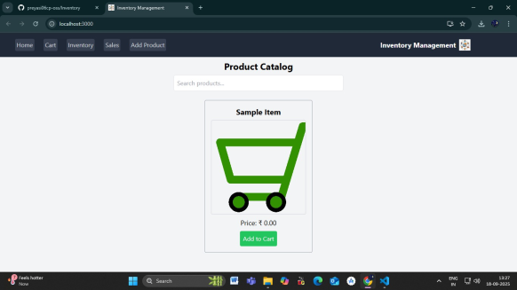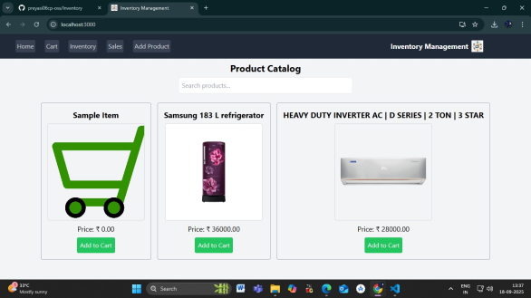

# Conclusion:

The Store Manager simplifies store operations by organizing products, sales, and inventory in one place. It improves efficiency, reduces errors, and provides a scalable solution for future growth.